**PROGRAMMING LANGUAGE USING C++**

**COM313 (PRATICAL)**

**AFOLABI TAIWO ABAYOMI**

**MARTIC NO: 19/69/0053**

**DEPARTMENT OF COMPUTER SCIENCE**

**MOSHOOD ABIOLA POLYTECHNIC OJERE, ABEOKUTA.**

**FEBUARY, 2024.**

**ACTIVITIES 1**

1. From your knowledge, what do you understand by Library Function?

**A library function**, also known as a library routine or subroutine, refers to a precompiled set of code that performs a specific operation or set of operations. These functions are usually bundled together into a library, which is a collection of modules or files containing code that can be reused by various programs.

Libraries serve the purpose of promoting code reusability, modular programming, and efficiency in software development. Instead of writing the same code for common tasks in multiple programs, developers can use library functions to perform specific operations without having to recreate the underlying logic.

There are two main types of libraries:

1. **Static Libraries:**

* Code from a static library is incorporated into the executable file of the program during the compilation process.
* The advantage is that the resulting executable is standalone and doesn't rely on external library files.
* However, if the library is updated, the program needs to be recompiled to include the changes.

1. **Dynamic Libraries:**

* Code from a dynamic library is linked to the program at runtime.
* The program includes references to the dynamic library but doesn't contain the library's code.
* Dynamic libraries can be updated independently of the program, allowing for easier maintenance and updates.

1. There are several library function, list &explain 10 of them?
2. **iostream**: Input and output stream operations.
3. **cmath**: Mathematical functions.

* sqrt(): Square root.
* sin(), cos(), tan(): Trigonometric functions.
* log(), exp(): Logarithmic and exponential functions.

1. **string**: String manipulation functions and operations.

* length(), size(): Get the length or size of a string.
* substr(): Extract a substring.
* find(): Find the position of a substring.

1. **vector**: Dynamic array implementation with functions to manipulate elements.

* push_back(): Add an element to the end.
* pop_back(): Remove the last element.
* size(): Get the number of elements.
* at(), []: Access elements by index.

1. **algorithm**: Generic algorithms on sequences (e.g., arrays or containers).

* sort(): Sort elements in a range.
* find(): Find a value in a range.
* max(), min(): Find the maximum or minimum element.

1. **iomanip**: Input/output manipulators for formatting.

* setw(): Set the width of the next input or output field.
* setprecision(): Set the precision of floating-point output.

1. **fstream**: File stream operations.

* ifstream: Input file stream.
* ofstream: Output file stream.
* fstream: File stream for both input and output.

1. **ctime**: Date and time functions.

* time(): Get the current time.
* ctime(): Convert time to a string.

1. **cstdlib**: General-purpose functions and macros.

* rand(): Generate a random number.
* atoi(), atof(): Convert string to integer or floating-point.

**ACTIVITIES 2**

1. With the aid of screenshot, highlights the steps you take to install Dev C++
2. I visit website, <https://sourceforge.net/projects/orwelldevcpp/> (**Version: 6.3**)
3. The first step while we start the installer is to select the language of our choice as shown in the below screenshot.

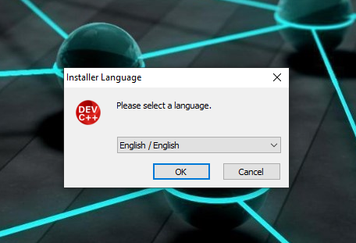

1. 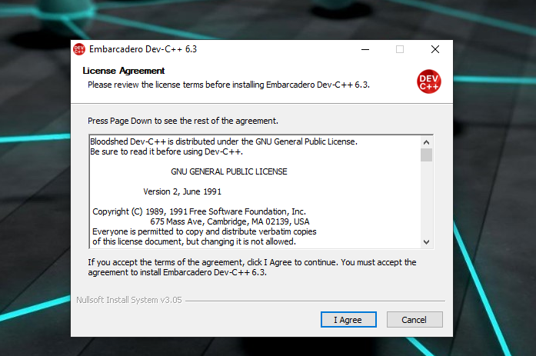 Once you select the appropriate language, you have to agree to the license agreement that pop-ups
2. Next, we are asked to select the components that we need to install as a part of the dev-C++ installation.

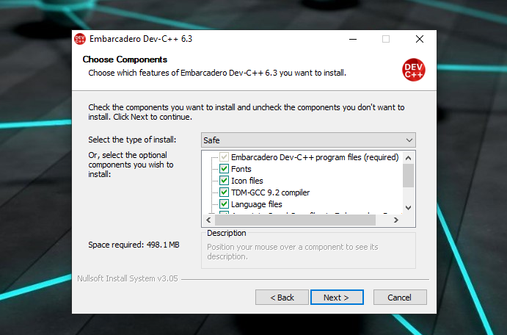

1. Now the installer prompts the user for the destination folder where the dev-C++ files/libraries etc. are to be copied.

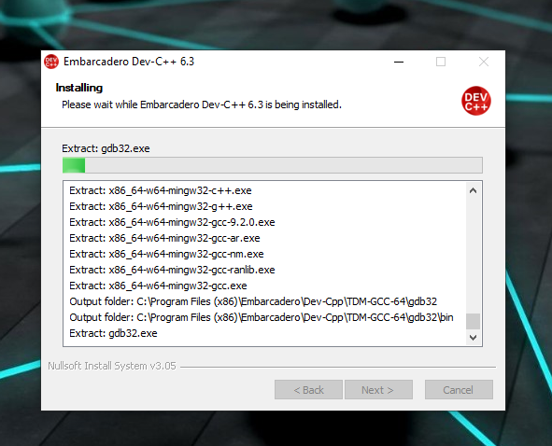

1. Installation finished

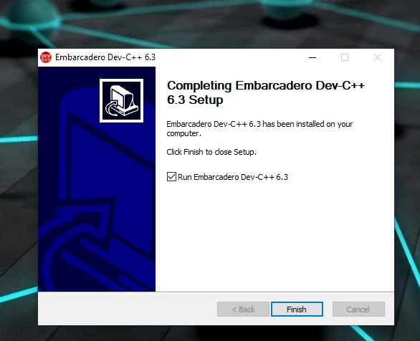

1. Welcome Page

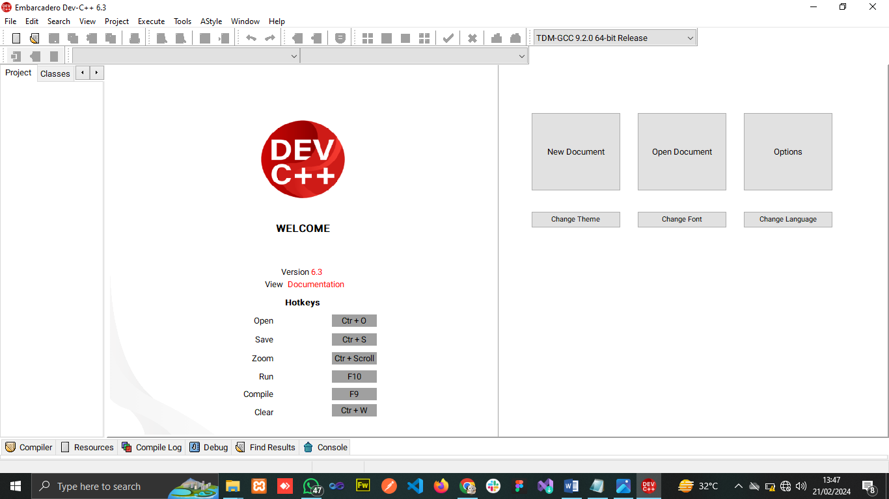

1. Write a C++ program to display first letter of your surname in Blocks of asteric(*) wide and 7 line long

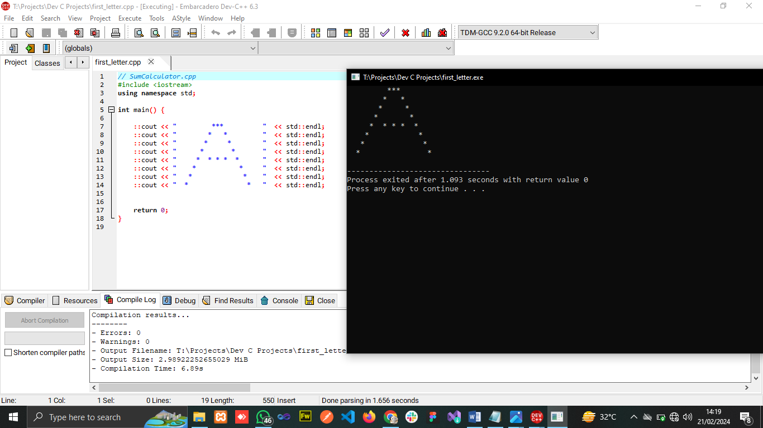

1. Write C++ program to displauy “HELLO” in long block letters, where each letters is 7 lines high & 5 dot wide

